Welcome to Cookstown Nursery School

PROSPECTUS
2023

Cookstown Nursery School
Molesworth Road , Cookstown, BT80 8PF
Tel: 028 867 64451
Email:info@cookstownns.cookstown.ni.sch.uk
www.cookstownnurseryschool.co.uk

Vision Statement

Within our school, we endeavour to provide a safe, happy and stimulating environment which supports children’s learning and celebrates their academic and non-academic achievements. We encourage them to become independent learners and thinkers.
Children, parents, staff and governors all demonstrate a strong sense of identity with and loyalty to the school, and everyone associated is committed fully to the wellbeing and development of the children.

Central to this vision is the development of our caring ethos:

“At Cookstown Nursery School, together we aim to provide a warm and welcoming environment where everyone in the school community will feel safe, respected and valued. Children will be nurtured, respected and encouraged to achieve their aspirations and become life-long learners.”

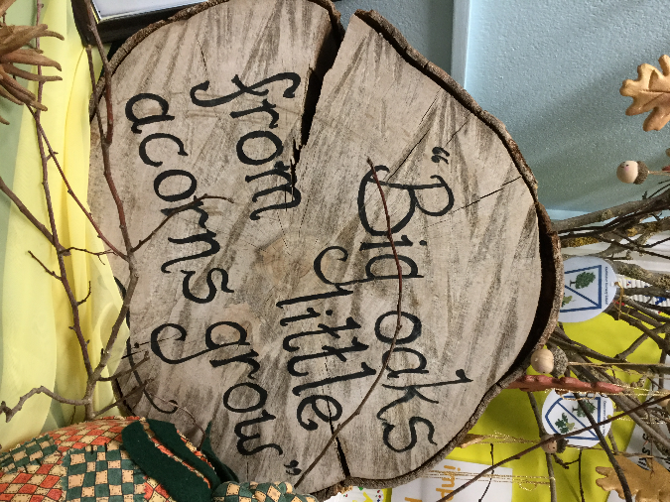
Welcome to Cookstown Nursery School
from the Principal
Dear Parent/Carer,
Thank you for taking the time to read our prospectus. I hope you find it both useful and informative. Choosing the pre-school provision for your child is an important decision as it is the first step on their educational journey. As a mother, I understand the importance of making the right decision and ensuring it is somewhere your child will be nurtured, supported and motivated to go to each day. Cookstown Nursery School is an nurturing, welcoming, stimulating and supportive environment where everyone is valued and the children are provided with an excellent foundation for learning facilitated by experienced staff.
The learning experiences in each class are led by qualified teachers and supported by nursery assistants. We offer 52 fully funded places for children in their pre-school and pre pre-school year and have a long standing tradition of providing quality pre-school education in the Cookstown area. The 52 places are allocated according to the criteria drawn up by the Board of Governors of the school.
We are delighted to be able to offer face to face visits with prospective parents again and welcome all interested to visit our open day on Thursday 4th January between the hours of 2-4pm and 5-7pm. If you are unable to attend on this date, please feel free to contact our school to make alternative arrangements to visit on a date more convenient for you.
We look forward to welcoming you and your child to our school in the near future. Best Wishes and thank you for considering our school as the first important step in your child’s education. We aim to contribute by providing a strong foundation for your child’s future educational journey.
Best Wishes
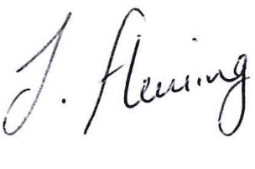
Mrs Julianne Fleming
(Principal)

ABOUT OUR SCHOOL
Cookstown Nursery School is a double unit nursery school conveniently situated on the Coolnafranky Demesne, in the centre of Cookstown and caters for 52 children of pre school age. The school is open to all, with preference given to those children who live within the local catchment area. Cookstown Nursery School has an excellent reputation and offers all children a wonderful learning experience.

The school is spacious, well-resourced and has a team of highly trained, professional staff who ensure a friendly and happy atmosphere where children can learn through fun and enjoyable activities / experiences.

Features of our inside environment include:-
-A large spacious entrance hall with attractive displays, parent information and tv screen displaying photographs of the learning experiences of the children.
-Two main spacious classrooms each with their own bathrooms and story rooms.
-A large multipurpose resource room for supporting children with special educational needs/ large group activities.
-Large covered annex area complete with indoor sand pit, wooden castle to complement learning within the classroom areas.

Our spacious, well planned outdoor area allows for an extensive range of exciting and stimulating areas for imaginative, creative and physical play.

Features of our outdoor environment include:-
-a slide,
-variety of climbing equipment including wooden bridge/ balance beams.
-a mud kitchen
-large sand pit
-large wooden shed
-playground with a variety of bicycles, tractors and other wheeled equipment.
-large soft play space for imaginative / open ended play activities.

The children are divided equally between both classes and we operate in an open planned setting. The curriculum is well planned by all staff and aims to develop the children’s curiosity, independence, physical and emotional well being, their self confidence, self esteem and social interaction skills. Children are given opportunities for both indoor and outdoor play in addition to having visitors to school and trips outside of school to broaden their experiences, knowledge and skills and prepare them for their future education.

The staff within our school encourage the development of a friendly and caring family atmosphere, bridging the gap between home and school. We aim to work closely with parents and the wider community for the long term benefit of children within our care.
There are occasions when some children may require additional assistance with their development and we will work closely with parents and other professionals to ensure these needs are met in order for them to overcome any difficulties they may have.
OUR CURRICULUM
Our curriculum is based on the Northern Ireland Pre School Curricular Guidance which is broad and balanced. Children are allowed to make choices and are provided with opportunities through play and other experiences to develop learning associated with:
❖ Personal, Social and Emotional Development
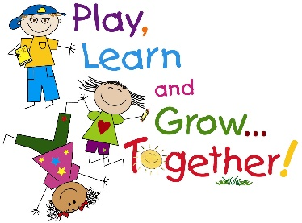
❖ Physical Development and Movement
❖ The Arts
❖ Language Development
❖ Early Mathematical Experiences
❖ The World Around Us
At Cookstown Nursery School we endeavour to create a stimulating, learning environment and encourage the children to learn through exploration and active participation.
We hope the information within this prospectus will give you an insight into all the exciting things which happen in our school and appreciate the range of experiences we can offer your child.

LOCATION MAP
Our school is located within the Coolnafranky Demense which shares site with Cookstown High School and Cookstown Primary School. The main entrance to our school is via the school avenue via blue gates on Molesworth Road (opposite Lidl/Argos).

For safety reasons parents must park in the main top car park and use the pathway to walk to our school . Cars must not be driven down to school grounds when collecting and dropping off children.

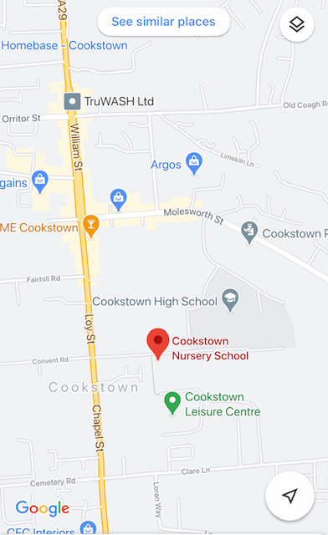

There is also pedestrian access to our school from the Courthouse Avenue or from Cookstown Leisure Centre.

School Management Type: Controlled

The school is under the control of:-
Education Authority (Southern Region)
3 Charlemont Place
Armagh
BT61 6AX
Tel: 028 3751 2200

Our school address:
Cookstown Nursery School
Coolnafranky Demense
Molesworth Road
Cookstown
BT80 8PF
Tel: 028 867 64451
Email: info@cookstownns.cookstown.ni.sch.uk
Website: www.cookstownnurseryschool.co.uk

Principal: Mrs Julianne Fleming BSc EYE Hons PGCE

If you wish to hear more about our school or have any questions, please do not hesitate to contact us via the methods above.
Further information about our school can be found on our website.

APPLICATION PROCESS

All children in their Pre-School year (born between 2/7/19- 1/7/20) are entitled to apply for a place in Cookstown Nursery School. We would also encourage children in their pre pre school year (born between 2/7/20 – 1/7/21) to apply as there is the possibility we will be able to offer some of them a place too.
Application forms for admission to Nursery School in September 2023 will be available to complete online at www.eani.org.uk/admissions from 12 noon on Tuesday 9th January 2024. Forms must be submitted by 12 noon on Friday 26th January 2024. If you have difficulties accessing the online forms, please contact the EA admissions helpdesk on 028 9598 5595 or by emailing preschooladmissions@eani.org.uk

Any applications submitted after this date will be classes as late and won’t be considered until stage 2.
Our school admissions criteria will be available on the above website from Tuesday 12th December 2023. After submitting an application on the Citizen Portal, you will receive a confirmation email.
Within 3 days you will then receive another email with a unique link where you can securely upload your child’s birth certificate and other supporting documents (e.g. if applicable benefit verification documents). These documents must be uploaded by noon on 4th February 2022.

There is a video available on our school website and on the Education Authority website which shows how to complete the application process.

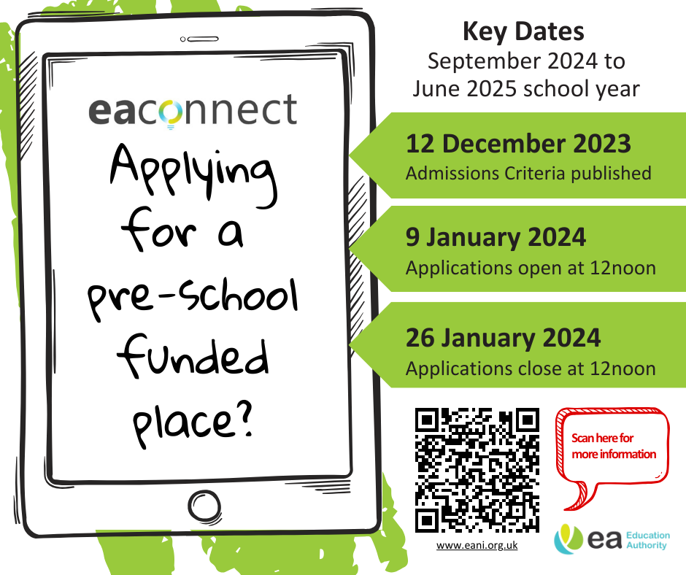

SETTLING IN NEW CHILDREN

We try to make the move from home to Nursery School as smooth and trouble free as possible for you and your child. Before starting nursery parents are asked to complete a transitional booklet which allows staff insight into your child’s likes and dislikes. You and your child will be invited for a visit during our transition day in August which will give your child the opportunity to familiarise themselves with our school and the staff. From the beginning of the first term, the children are admitted on a staggered basis each week in order to establish a good relationship with each child and to ensure that each child has settled reasonably well before any other children a join the class.
Your child’s length of session will depend upon a number of factors including how well they have settled, how comfortable they are within the setting and their wellbeing. We take our cues from the child and will not increase times until they are comfortable. Staff will guide you through this process.
Throughout the year in Cookstown Nursery School we will endeavour to do everything possible to ensure that your child is well settled, happy, content and enjoying nursery life.

MEET THE TEAM

Principal & Teacher: Mrs Julianne Fleming
Assistant Teacher: Mrs Louise Mallon
Nursery Assistants: Mrs Joanne Harkness (Job Share)
Mrs Cathy Hammond (Job Share)
Miss Rebecca Curry
Additional Needs Assistants: Mrs Ann Bolton
Secretary: Mrs Ann Bolton
Catering Supervisor: Mrs Jackie Purvis
Building Supervisor: Mrs Rhonda Donnelly

OUR SCHOOL DAY

8.30am-8.45am Staff Preparation
8.45am-9.00am Doors Open/ Welcome of children
8.45am- 11.15am Choice of Indoor/ Outdoor play
11.15am-11.30am Tidy up time
11.30am- 12.00 Noon Story/Rhyme/Preparation for lunchtime
12.00Noon-12.45pm Lunch time
12.45pm- 1.15 pm Story/Rhyme/Free Play/Outside Play
1.15pm Home Time
1.30pm-2.30pm Staff Preparation
2.30pm- 3.00pm Staff Break
3.00pm Teacher record keeping/ Principal administration

- Our doors will be open from 8.45 am. Whilst waiting outside in our outer hall, please ensure your child is supervised at all times.

- Under 18’s must not be responsible for leaving or collecting children.

- Children must be dropped off or collected by a responsible adult.

- Please advise staff if anyone different will be collecting your child. We will not release children to anyone unknown to staff unless we have been notified by the parent. This often causes embarrassment for all those concerned if we are unable to release the child and need to contact parents to verify identity.

- For the safety of the children and security of the nursery, the front door is locked and has a door entry system in place. On arrival, please press the buzzer and wait for a member of staff to greet you. Please do not pin back the front door for prams/buggies etc as this only compromises the safety of our children.

PASTORAL CARE,CHILD PROTECTION AND POSITIVE BEHAVIOUR
We in Cookstown Nursery School have a primary responsibility for the care, welfare and safety of the children in our care. The duty of care is viewed as a partnership between the teachers, parents and support services. We aim to provide a safe, caring and supportive environment in which the children feel safe and secure and in turn will promote their learning.
We have a comprehensive Safeguarding policy and Intimate Care policy in place which are available to read on our school website or available from school . Our Safeguarding team is made up of Mrs Fleming (Principal), Mrs Mallon (class teacher) and one of our Governors, Mrs Sherman.
All the staff and volunteers have been subject to appropriate background checks (Access NI) and guidelines have been drawn up to guide their behaviour with the children. During the school day, it may be necessary for the staff to change your child’s clothes if they have had a toileting accident but this will not be done without your permission, which we have already requested on the Child Protection Permission Form completed before your child starts school.

The Designated Teacher for child protection issues is Mrs Julianne Fleming and her Deputy is Mrs Louise Mallon.

In Cookstown Nursery School we place a strong emphasis on positive behaviour management. Our aim is to help our children become self-disciplined, accept responsibility for their own actions and respect others and their work. We strive to do this through the implementation of the Golden Rules and working in partnership with our parents/carers. We use a variety of strategies within the school including ‘Star of the Week’, Rainbow moments, positive praise, behaviour charts and sticker incentives.

HOW A PARENT CAN RAISE A CHILD PROTECTION CONCERN

If a parent has a child protection concern, they can follow the guide below.
I have a concern about my/a child’s safety

If I am concerned, I can talk to
Mrs Julianne Fleming
(Principal/Designated Child Protection Teacher)
or to
Mrs Louise Mallon
(Nursery Assistant/Deputy Designated Child Protection)

If I am still concerned, I can talk/write to the Chair-person of the Board of Governors, Mr P Mitchell
or
Governor for Child Protection
Mrs O Sherman

At any-time, I can write or talk to a Social Worker on
Gateway Team Tel: 08007837745 (Free Phone from Landline)
Tel: 028 374 15285 (Southern Region)
or the Police Tel: 101 (Ext 30299)
Out of Hours duty social worker (028 950 49999)

If I am dissatisfied with the school’s response to my complaint, I can contact the Public Services
Ombudsman on 0800 343 424

CHILDREN WITH ADDITIONAL NEEDS
As an inclusive school, children with special educational needs are admitted to the Nursery School in every possible circumstance. Whilst provision for the pupil is co-ordinated by the Special Education Needs Co-ordinator (Mrs Julianne Fleming), all members of staff are involved in providing the support to integrate the child as fully as possible within the group, giving them access to the same materials, activities and experiences as the other children in the class. With parental permission, we also work in conjunction with outside agencies in order to provide the most effective way to make their nursery experience rich and fulfilling while meeting their needs.
Teachers will continually monitor progress and if they find that a child is experiencing difficulties they will give additional help and support as necessary. An Individual Education Plan will be drawn up, progress monitored and the plan reviewed.
We are also committed to providing for the needs for whom English is an additional language. Extra support through small groups help these children to integrate fully into the life of our school.
If you have a child who has additional needs, please get in touch with us at the time of applying and we can discuss your child’s needs and the agencies currently involved with them.

SCHOOL UNIFORM
Uniform is not compulsory however it adds much to the ethos and identity of our school. It makes it easier for children to develop independence and also protects everyday clothing.
Our uniform consists of :-
-Navy sweatshirt with school logo
-White polo shirt
-Navy skirt/ track bottoms
- Trainers/ shoes with Velcro (not laces/zips)

Our uniform can be purchased from Wallace’s (Kee’s) in Cookstown . Please ensure all clothing items are LABELLED clearly.
SCHOOL MEALS/HEALTHY SNACK/SCHOOL FUND

In Cookstown Nursery School we are committed to promoting healthy eating and feel it is imperative to maximise every opportunity to influence the children’s eating habits.
Meals are freshly prepared and transported from our nearby primary school kitchens. A healthy and nutritious meal is provided for all children as an integral part of our nursery day as it develops social skills and independence. Meals cost £12.50 per week (£2.50 per day) Information on making free meals application is available from EA website.

A healthy snack is available each day to the children along with the option of milk or water. The children can self-select their snack each day and then have the opportunity to sit and chat to their peers while they are eating. They are also encouraged to pour their own milk/water.

Our snack items include:
-toast - pancakes
-crackers/cheese -bread muffins
-fruit -wheaten bread
-raw vegetables -yoghurts

As the nursery school is part of the State Education system, there is no daily charge for children to attend. However, we do ask for a weekly contribution towards school funds (£2.50 per week). This money is used to provide daily snacks for the children to have with their milk, baking activities, parties, visiting entertainers, treats for the children and any outings we go on.

Please make sure you let staff know of any food allergies or intolerances your child has. Please do not send food into school with your child.

SCHOOL HOLIDAYS
Parents will be notified of our annual holiday list as soon as possible. We try to arrange similar holidays with our main feeder school, Cookstown Primary School, to facilitate parents with children attending both nursery and primary classes but it is not always possible to co ordinate closures as both schools will be engaging in different development work.
Please be aware that the school may have to close during local elections.

MEDICINES IN SCHOOL
Parents should be aware that no medicines are permitted to be sent into school with the exception of life saving medication. In this case, staff will facilitate the taking of such medicines, but only if the parent provides written permission for it’s administration and clear, detailed instructions for its administration.
The school has two trained First Aiders. They are trained every 3 years as per EA directive. A defibrillator is held on the premises.
Medicines for routine childhood illnesses such as coughs/ colds are not permitted to be given at school. If a child is unwell, the best place for them to be is at home.

HEALTH & SAFETY AT SCHOOL
The health and safety of your child is of utmost importance and we make every effort to maintain a safe clean healthy environment for the children.
Medical Issues
All permanent members of staff are trained in anaphylaxis and the use of inhalers. It is very important that we are aware of any medical issues that children have so that we can ensure their safety. Should you have any concerns about medical issues your child may have or wish to discuss them, please contact the Nursery.
Nut free school
We want to ensure that all our staff and children are safe at nursery especially when there are known allergies therefore we are a nut free school.
Accidents
Four of our permanent teaching staff are paediatric first aid trained. We will always inform parents about any minor accidents when children are collected and we will telephone immediately if the accident is of a more serious nature.
PARENTAL PARTNERSHIP

“Parents/guardians/carers are the child’s first and continuing educator and as such have a central role to play in pre-school life.”
(Pre School Curricular Guidance, DENI,2018)
We are pleased to say that our parents have always shown great interest and support for our school in the past and we look forward to this continuing in the coming year. The education of your child is a partnership between home and school. You as parents, have been your child’s first teacher and we will strive to work closely with you with the aim of developing the full potential of the children within our care.
We work in close partnership with parents/carers of all our children. Throughout the year, parents have many informal opportunities to discuss their children’s progress and two formal meetings are arranged each year. Informal opportunities to share in their children’s learning are also provided through Stay and Play sessions which enable you to come to Nursery School and join in the activities with your child.
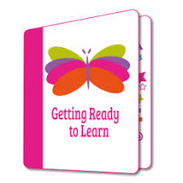
We have an extensive home learning programme. We participate in the Getting Ready to Learn Programme which includes the Big Bedtime Read, Happy Healthy Kids and Education Works. These programmes help support the link with home and offer ideas and activities to be doing at home to help further support each child’s development.
We also provide monthly home learning sheets which include ideas and activities that can be carried out at home to reinforce the children’s learning. Information about the activities children are involved in during the time they are in the Nursery School will be shared in our monthly newsletters, school website and on the private See Saw app which is only accessible by current parents/carers and staff .
There are also opportunities for parents to meet with your child’s class teacher each term. This is a welcome chance for staff to share how your child is progressing in nursery school but it is also an opportunity for parents to share with the staff if they are having any difficulties at home such as behaviour, sleep patterns etc.

LINKS WITH PRIMARY SCHOOLS
We aim to make the transition from nursery to primary school as smooth as possible for the children. Throughout the year as part of the transition procedure we endeavour to visit some of the local primary schools and where practical, invite Year 1 teachers to visit us in the Nursery School. During the month of June, Year 1 teachers from the local Primary Schools come along to meet the children in Nursery School. This helps to familiarise the children with their new teachers. We also engage in a range of transition activities including small groups of children who will be attending certain schools together. Activities may include sharing the primary school transition booklets, talking about their new uniforms, new school environments and names of new friends. We also share transition reports with feeder schools of which the children are attending.

LINKS WITH THE COMMUNITY
We have developed links with our local community through visits to the police station, fire station, the local library or by having visits from nurses, hairdressers and the dentist to name but a few. We have strong links with the various support agencies available within the community such as health visitors, and will endeavour to sign post those parents who require it to avail of such services.

In addition to this we take the children on local walks and outings in order to extend the work being carried out in the classroom.

The information in this booklet shows life in Cookstown Nursery School and is correct at time of publishing. However, it cannot be assumed that changes will not occur in school organisation during the course of the school year or in subsequent years.

We hope you found this prospectus informative. Please get in touch via telephone or email if you have any questions. Hopefully we will meet you and your child in the near future. Take care and best wishes.

